Can planting trees reduce urban air pollution in Auckland City? A NetLogo sensitivity study

Tender 6: Urban pollution in Auckland City

Executive summary
This report uses the NetLogo Urban Suite Pollution model to show the public how planting trees changes air pollution and how much the answer depends on other settings. Planting was the strongest lever tested. With no planting, mean pollution at tick 100 was about 0.066 model units in all 20 runs. At the baseline planting rate of 0.05, it fell to about 0.002 (roughly 97% lower), and at 0.5 it was close to zero. Pollution rose with more power plants (mean 0.0017 with one, 0.0096 with six) and with a higher polluting rate (0.0007 at rate 1, 0.0103 at rate 7). All tested scenarios with planting had lower mean pollution than the no-planting baseline, although equivalent high-emission scenarios without planting were not tested. Population collapse time varied widely between runs, and the diffusion rate and power-plant layout experiments showed no clear effect on collapse time, although their direct effects on pollution were not established. Results are in model units from 10–20 runs per setting, so they show direction and relative size, not real concentrations in Auckland.
1. Background and client question
The tender asks for a tool that educates the public about the benefits of planting trees to reduce air pollution in Auckland City. Here, the tender’s urban air pollution question is applied to Māngere as a local Auckland case context. In Māngere, the Māngere Ngahere project aligns with Auckland’s Urban Ngahere Strategy target of at least 15% canopy cover in every local board area (Auckland Council, 2023). Real air quality in Auckland is mixed: the 2022 regional annual average for PM2.5 was above the 2021 World Health Organization guideline of 5 µg/m³, although the Unitary Plan 24-hour target was not exceeded (Boamponsem, 2023). Māngere lies near Auckland Airport and State Highway 20, making it a relevant local context for discussing urban pollution. However, the model represents pollution through simplified power-plant sources rather than explicitly modelling airport activity or road traffic, and it is not calibrated to measured data.
Studies in the United States estimate that urban trees remove large amounts of pollution, about 711,000 tonnes a year across the country (Nowak et al., 2006), and that removal of fine particles by trees in ten cities has measurable health value (Nowak et al., 2013). Reviews are more cautious. Street trees can help, but their effect depends on the species, location, and planting density (Salmond et al., 2016), and tall tree canopies in narrow street canyons can make air quality worse by trapping pollution (Abhijith et al., 2017). The model used here does not represent streets or buildings, so its value here is to show which settings matter most, not to give exact predictions.

2. Methods
The NetLogo Urban Suite Pollution model (Felsen & Wilensky, 2007) was used in NetLogo (Wilensky, 1999), with the modifications described below. In the model, power plants emit pollution that spreads between neighbouring patches; people move around, reproduce and plant trees, and trees reduce pollution. The world wraps around its edges, so a pollution plume leaving one side re-enters from the opposite side. The baseline settings were: initial population 30, birth rate 0.10, planting rate 0.05, two power plants, polluting rate 3, and diffusion rate 0.8. Three additions were made to extend the model without altering its rules: the polluting-rate slider maximum was raised from 5 to 9 so that rate 7 could be run, a diffusion-rate slider was added so that diffusion could be varied, and two power-plant layouts (spread and clustered) were created to test where sources are placed.
Layouts were changed only by where the two power plants were placed. In the baseline, the model places them at random. In the spread layout, one plant was in the centre and one in a corner. In the clustered layout, the two plants were in two corners; because the world wraps around, corners touch across the edges, so these plants behave like one hot spot.
One setting was changed at a time while the others were left at baseline. Tested values were planting rate 0, 0.05, and 0.5 (pollution) and 0.02, 0.05, 0.1, 0.2, and 0.5 (collapse time); number of power plants 1, 2, 4 and 6; polluting rate 1, 3, 5 and 7; diffusion rate 0.2, 0.5, 0.8, and 0.9; and plant layout (spread, baseline, clustered). In the pollution experiments (Figures 1, 3 and 4) the baseline is the same 20 runs. For diffusion rate, collapse time only was recorded, not pollution at tick 100, so it was assessed through population survival. The same modified model was used for every experiment; the spread and clustered versions were used only for the layout test.
The model was run in two ways. For the pollution experiments (Figures 1, 3 and 4), each run was started from a scripted command in the Command Center that calls the same procedures as the setup and go buttons, and the mean pollution of all patches was recorded at tick 100. For collapse time (Figures 2, 5 and 6), the setup and go buttons were used, and each run continued until no people remained, with no upper limit on run length; collapse time is the number of ticks this took. A run that never collapsed was left out of the collapse-time results. Each setting had 20 runs, except diffusion rate and the spread and clustered layouts, which had 10 each. The baseline in Figures 2 and 6 is the 20 setup-and-go runs at planting rate 0.05. The model is random, so every run differs.
Analysis was done in MATLAB. One script per figure reads an Excel file of run results and plots each run as a grey dot, jittered sideways so dots do not overlap, with a blue line joining the mean of the included runs. Because excluding non-collapsing runs pulls the collapse-time mean down, medians and ranges are also reported.

3. Results
3.1 Planting trees strongly reduces pollution
Figure 1 shows that planting rate had by far the largest effect. With no planting, pollution was almost identical in every run (0.063–0.067). At the baseline rate of 0.05, the mean was 0.0021, and every run was below 0.0065, which is lower than every no-tree run. At 0.5, the mean was 0.0001 and most runs were at or near zero. So the first small amount of planting removes most of the pollution, and extra planting adds little.
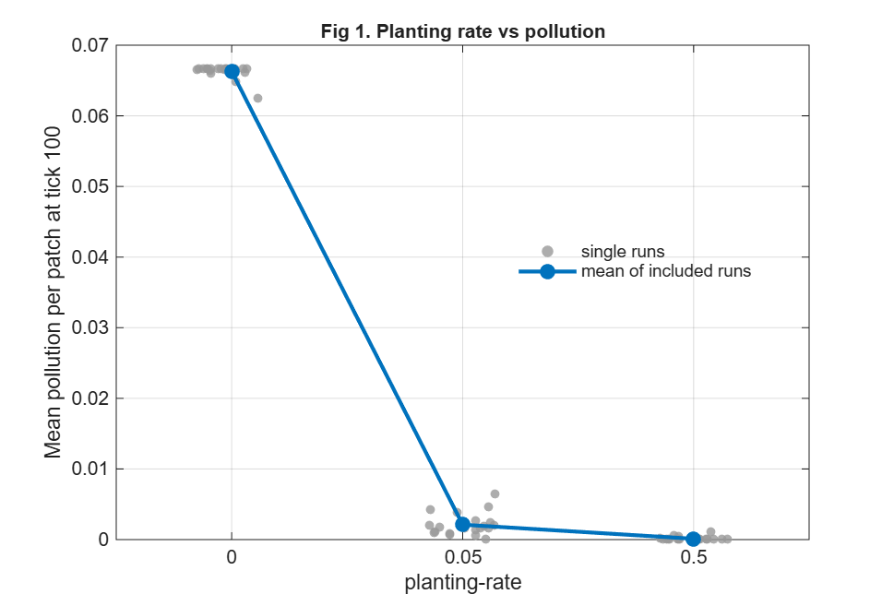
Figure 1. Mean pollution per patch at tick 100 for three planting rates (20 runs each).

3.2 Planting and survival time
Figure 2 shows collapse time for planting rates 0.02 to 0.5. Medians were between 389 and 595 ticks and means between 665 and 942, with no clear trend: the ranges overlap heavily (130–5157), and some runs lasted past 2000 ticks, including one of 5157 at rate 0.1. Each rate had 17–20 valid runs. Collapse time is therefore treated as weak evidence only.
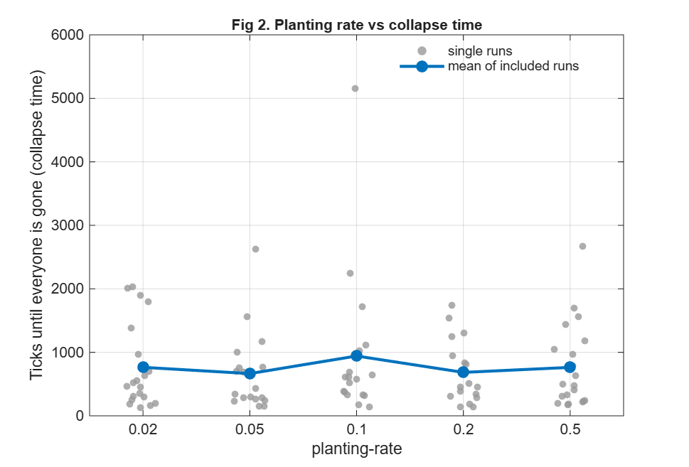
Figure 2. Collapse time for planting rates 0.02 to 0.5 (setup-and-go runs, no time limit). Runs that never collapsed are excluded.

3.3 More power plants raise pollution
In Figure 3 mean pollution rose with the number of power plants: 0.0017 (one), 0.0021 (two), 0.0056 (four) and 0.0096 (six). One and two plants are hard to tell apart, but four and six clearly differ, and the spread between runs grows with more plants (maximum 0.029 at six). Six plants with trees gave a mean of 0.0096. This cannot be compared directly with the no-tree result (0.066), which used two plants, because six plants without trees were not run.
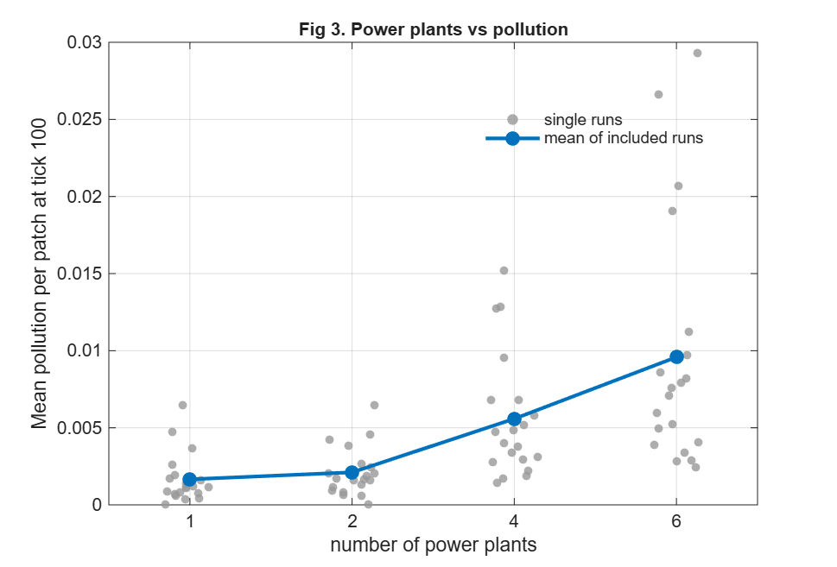
Figure 3. Mean pollution at tick 100 for 1, 2, 4 and 6 power plants (20 runs each).
3.4 Higher polluting rate raises pollution
Figure 4 shows the same pattern for the polluting rate. Means were 0.0007, 0.0021, 0.0050 and 0.0103 at rates 1, 3, 5 and 7. This was the most sensitive pollution input tested apart from planting, and its range at rate 7 is wide (0.003–0.034).
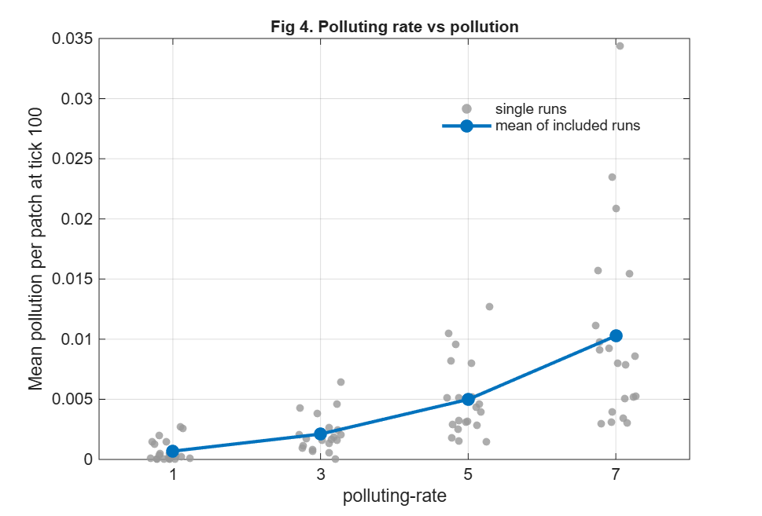
Figure 4. Mean pollution at tick 100 for four polluting rates (20 runs each).

3.5 Diffusion rate
Figure 5 shows collapse time (population survival, not pollution) for diffusion rates 0.2 to 0.9, with 10 runs each. The mean was highest at 0.2 (681 ticks) and lowest at 0.8 (333 ticks), but the dots overlap and no clear pattern is present. With 9–10 valid runs per rate, differences between rates cannot be separated from chance.
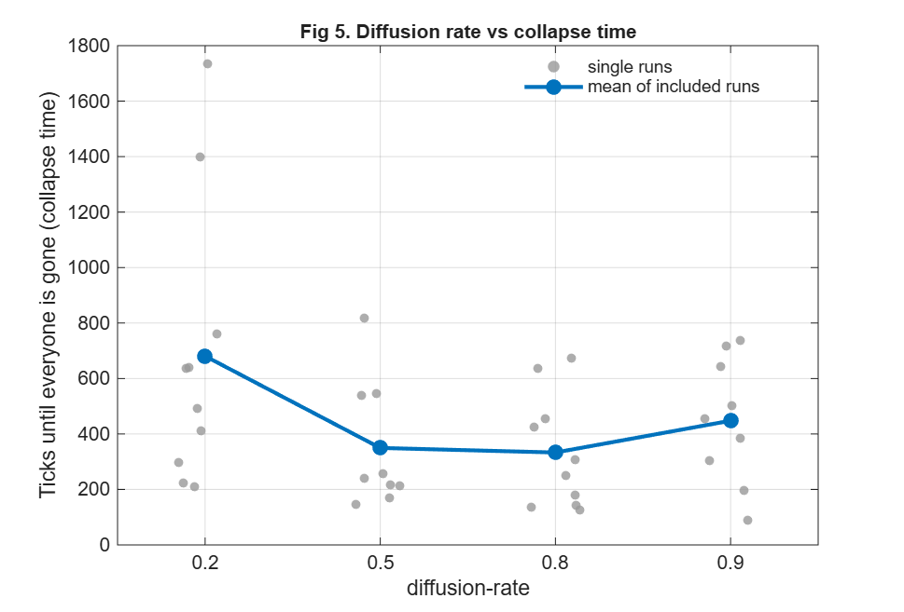
Figure 5. Collapse time for four diffusion rates (10 runs each; non-collapsing runs excluded).
3.6 Power-plant layout
Figure 6 compares spread, baseline and clustered layouts. Medians were 437, 389 and 292 ticks, but the ranges overlap almost completely (101–2622). The clustered case has the lowest median but also some very long runs. No clear effect of layout on collapse time was found, and pollution was not measured for the layouts.
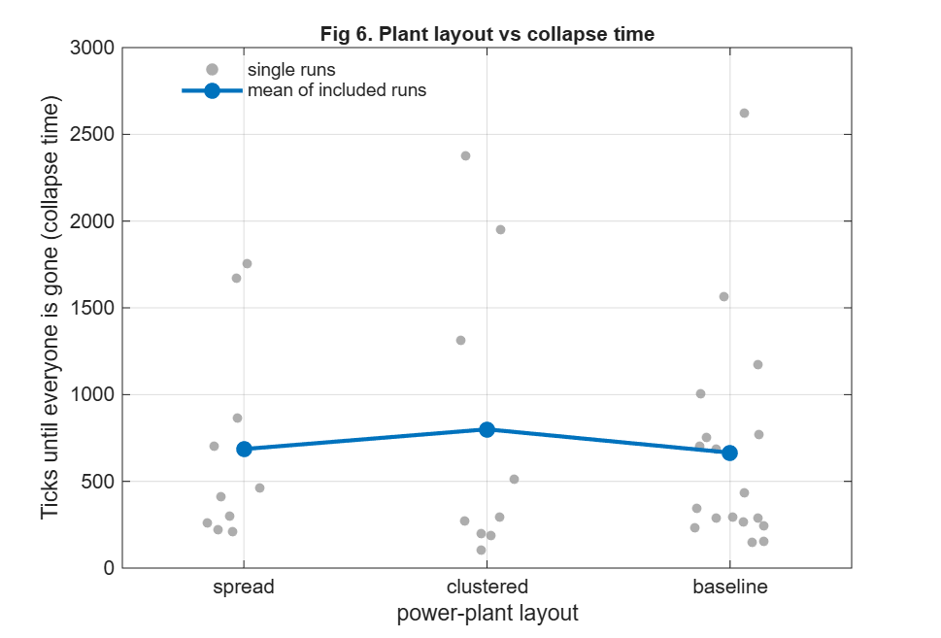
Figure 6. Collapse time for three power-plant layouts (spread and clustered 10 runs each; baseline 20; non-collapsing runs excluded).

4. Limitations and key sensitivities
The most sensitive settings were planting rate, polluting rate, and number of power plants, all acting on pollution. No clear effect on population collapse time was detected for the settings tested. The substantial variation between runs suggests that random processes may obscure differences between settings. Limitations of the model: it represents a simplified, flat urban area without streets, buildings, wind, traffic or tree species, so street-canyon effects reported in the literature (Abhijith et al., 2017) cannot be shown, and including them would be the main step toward a more realistic model; the tree effect on pollution is a rule of the model, so the size of the planting effect partly reflects how the model is built; results are in model units, not calibrated to measured data and not comparable with µg/m³. Limitations of the experiments: 20 runs only detect large effects, and 10 runs even fewer, so the diffusion and layout results could hide real differences; excluding runs that never collapsed biases collapse-time means downwards, which is why medians are given; one setting was changed at a time, so interactions were not tested; only three planting rates were run for pollution; six plants and polluting rate 7 were not run without trees; and diffusion rate and layout were tested only through collapse time, so their effects on pollution are untested.

5. Discussion
To answer the client: in this model planting trees is the most effective single action, and even a modest planting rate cuts mean pollution by about 97% compared with none. Reducing emissions also matters, since pollution grew steadily with both the number of sources and the polluting rate. For public education, the clearest message is that trees and emission reductions work together: plant trees, and keep cutting emissions as well. This agrees in direction with the large national estimates of pollution removal by trees (Nowak et al., 2006; Nowak et al., 2013).
The size of the tree effect should not be transferred directly to a real Auckland neighbourhood. A model patch is not a real place, and the effect of real trees depends on where they are placed (Abhijith et al., 2017). The model result is therefore best used to explain the principle, not to promise a specific reduction. Diffusion rate and layout showed no clear effect on survival time, but their effect on pollution was not tested.
6. Conclusions
In the NetLogo Pollution model, tree planting produced the largest reduction in pollution, while increasing the number of sources and their polluting rate increased pollution levels. However, population survival time varied considerably between runs, making clear effects difficult to establish. The observed 97% reduction reflects the model's behaviour and should not be interpreted as a prediction for Auckland. Although the model provides a useful tool for public education, its simplified representation of urban pollution limits its application to real neighbourhoods. Further development could incorporate traffic emissions, wind-driven pollution movement and urban structures, with model outputs subsequently evaluated against measured Auckland air-quality data..

References
Abhijith, K. V., Kumar, P., Gallagher, J., McNabola, A., Baldauf, R., Pilla, F., Broderick, B., Di Sabatino, S., & Pulvirenti, B. (2017). Air pollution abatement performances of green infrastructure in open road and built-up street canyon environments – A review. Atmospheric Environment, 162, 71–86. https://doi.org/10.1016/j.atmosenv.2017.05.014
Auckland Council. (2023, August 28). Ngaa Hau o Māngere Ngahere planting in Māngere-Ōtāhuhu. Our Auckland. https://ourauckland.aucklandcouncil.govt.nz/news/2023/08/ngaa-hau-o-maangere-ngahere-planting-in-mangere-otahuhu/
Boamponsem, L. (2023). Auckland air quality – 2022 annual data report (TR2023/8). Auckland Council. https://www.knowledgeauckland.org.nz/publications/auckland-air-quality-2022-annual-data-report/
Felsen, M., & Wilensky, U. (2007). NetLogo Urban Suite – Pollution model [Computer software]. Center for Connected Learning and Computer-Based Modeling, Northwestern University. http://ccl.northwestern.edu/netlogo/models/UrbanSuite-Pollution
Nowak, D. J., Crane, D. E., & Stevens, J. C. (2006). Air pollution removal by urban trees and shrubs in the United States. Urban Forestry & Urban Greening, 4(3–4), 115–123. https://doi.org/10.1016/j.ufug.2006.01.007
Nowak, D. J., Hirabayashi, S., Bodine, A., & Hoehn, R. (2013). Modeled PM2.5 removal by trees in ten U.S. cities and associated health effects. Environmental Pollution, 178, 395–402. https://doi.org/10.1016/j.envpol.2013.03.050
Salmond, J. A., Tadaki, M., Vardoulakis, S., Arbuthnott, K., Coutts, A., Demuzere, M., Dirks, K. N., Heaviside, C., Lim, S., Macintyre, H., McInnes, R. N., & Wheeler, B. W. (2016). Health and climate related ecosystem services provided by street trees in the urban environment. Environmental Health, 15(Suppl 1), Article 36. https://doi.org/10.1186/s12940-016-0103-6
Wilensky, U. (1999). NetLogo [Computer software]. Center for Connected Learning and Computer-Based Modeling, Northwestern University. http://ccl.northwestern.edu/netlogo/

